***Contents:***

**1. Origins and Historical Background: 2**

**2. Easter in Christianity: 3**

**3. Traditions and Symbols: 3**

**4. Date of Easter: 3**

**5. Modern Celebrations: 3**

**6. Conclusion: 3**

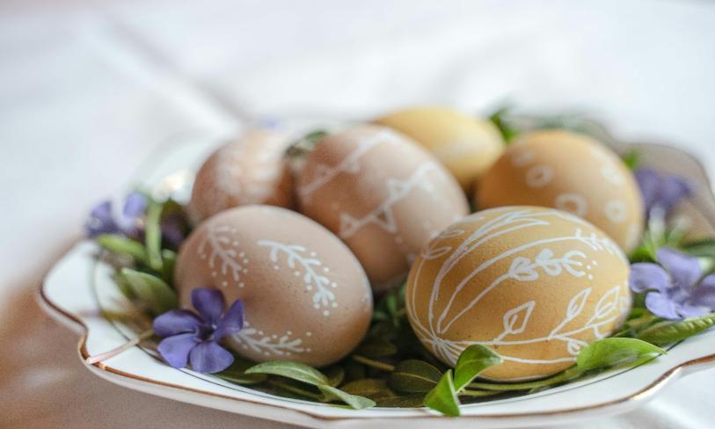

Easter is one of the most significant and oldest festivals celebrated by Christians worldwide. It commemorates the resurrection of Jesus Christ from the dead, a central belief in Christianity that signifies hope, renewal, and eternal life.

# **Origins and Historical Background:**

The origins of Easter can be traced back to ancient Jewish traditions and pagan spring festivals. The Jewish festival of Passover, which commemorates the Israelites’ liberation from slavery in Egypt, is closely linked to Easter. Jesus’ crucifixion and resurrection took place around the time of Passover, which is why Easter’s timing varies each year.Before Christianity, many pagan cultures celebrated the arrival of spring with festivals honoring fertility, rebirth, and renewal. Symbols such as eggs and rabbits were common in these celebrations, representing new life and fertility.

# **Easter in Christianity:**

In Christianity, Easter marks the end of Holy Week, which begins with Palm Sunday and includes Maundy Thursday (commemorating the Last Supper) and Good Friday (commemorating the crucifixion). Easter Sunday celebrates Jesus’ resurrection, which is considered the cornerstone of Christian faith.

# **Traditions and Symbols:**

Easter is associated with various customs and symbols. The Easter egg symbolizes new life and resurrection. The Easter bunny, originally a pagan symbol, became a popular figure associated with delivering eggs to children. Churches hold special services, and families gather for meals and festivities.

# **Date of Easter:**

The date of Easter changes every year because it is based on a lunisolar calendar. It falls on the first Sunday after the first full moon following the vernal equinox (around March 21). This method was established by the Council of Nicaea in 325 AD.

# **Modern Celebrations:**

Today, Easter is celebrated worldwide with religious ceremonies, family gatherings, and various customs like Easter egg hunts and festive meals.

# **Conclusion:**

Easter is a festival rich in history and tradition that celebrates the core belief of Christianity — the resurrection of Jesus Christ. Over time, it has also embraced symbols and customs from various cultures that highlight themes of renewal, hope, and new life. Today, Easter continues to be a meaningful occasion for millions around the world, blending religious significance with joyful celebrations.